**Summary:**

Basic SQL syntax: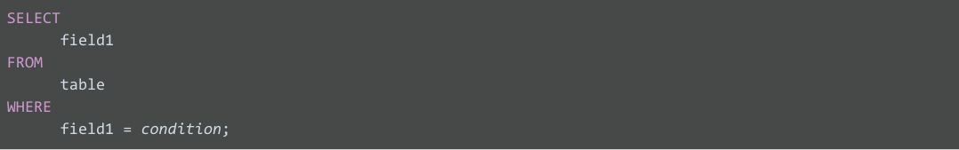

Some examples of where clause:

**WHERE field1 = 'Chavez'**

**WHERE field1 LIKE 'Ch%'**

Aliases:

***You create a SQL query similar to below, where <> means "does not equal":***

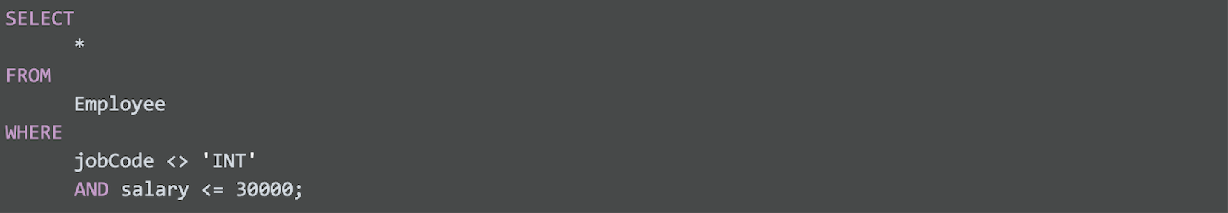

*Resources to learn more:*

[W3Schools SQL Tutorial](https://www.w3schools.com/sql/default.asp):

[SQL Cheat Sheet](https://towardsdatascience.com/sql-cheat-sheet-776f8e3189fa)

## 

## 

**Steps to plan a data visualization:**

### **Step 1: Explore the data for patterns**

### **Step 2: Plan your visuals**

### **Step 3: Create your visuals**

